Implementation of DBMS, Exercise Sheet 8
WS 2024 / 2025
- Insert the keys 12, 25, 5, 17, 30, 20, 40, 8, 15, 22, 27, 45, 10, 50, 35, 18, 13, 32, 38, 7, 24 in this order into an initially empty B+-tree of order 3 or 4. Show the resulting tree after each insertion.
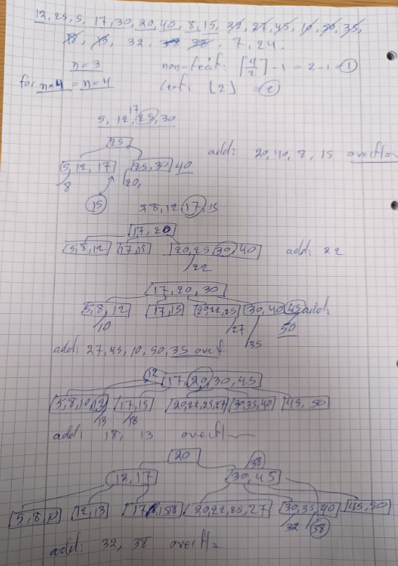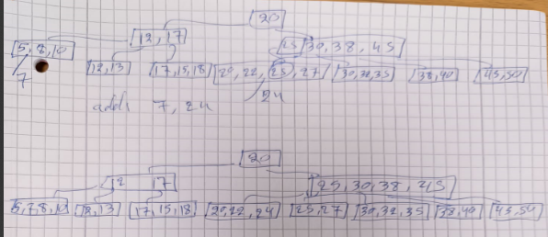
- Consider B+-trees of order 3. Give an example of a B+-tree with three levels whose set of keys could alternatively be represented in a B+-tree with two levels. Your example should consist of two trees:
a) One with three levels.
b) Another one with two levels containing the same set of keys.
- Suppose we have a B+-tree of order 4. We continuously insert the keys 1, 2, 3, ... into an initially empty tree. At the insertion of what key will the B+-tree first reach four levels?
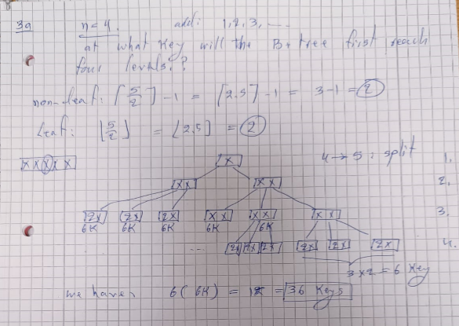

- Insert the keys 15, 30, 20, 10, 25, 35, 40, 50, 5, 45, 12, 22, 32, 17, 27, 8, 38, 42, 18, 13, 24 in this order into an initially empty B+-tree of order 5. Show the resulting tree after each insertion.
- Consider B+-trees of order 4. Give an example of a B+-tree with three levels whose set of keys could alternatively be represented in a B+-tree with two levels. Your example should consist of two trees:
a) One with three levels.
b) Another one with two levels containing the same set of keys.
- Suppose we have a B+-tree of order 2. We continuously insert the keys 1, 2, 3, ... into an initially empty tree. At the insertion of what key will the B+-tree first reach three levels?
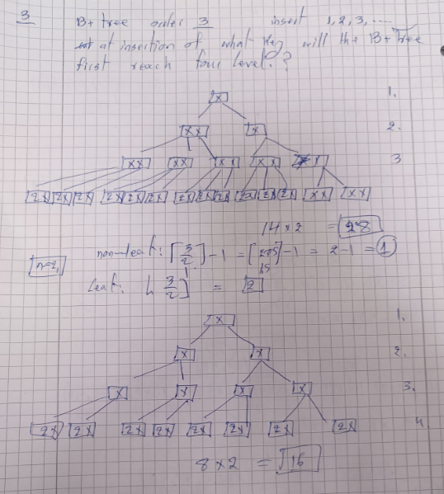
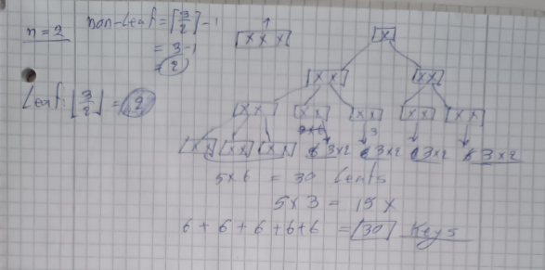
3) Suppose we have a B+-tree of order 3. We continuously insert the keys 1, 2, 3, ... into an initially empty tree. At the insertion of what key will the B+-tree first reach four levels?

To solve this problem, we need to understand the structure and behavior of a B+-tree of order 3. Let’s break down the solution step by step, explaining the concepts and reasoning behind it.

1. B+-Tree Basics:
- A B+-tree is a self-balancing tree data structure that maintains sorted data and allows for efficient insertion, deletion, and search operations.
- The order of a B+-tree determines the maximum number of children a node can have. For a B+-tree of order 3:
  - Each internal node can have at most 3 children.
  - Each leaf node can hold at most 2 keys (since the order is 3, and leaf nodes typically hold one fewer key than the order).

2. Insertion Process:
- When inserting keys into a B+-tree, the tree grows dynamically. If a node overflows (i.e., exceeds its maximum capacity), it splits into two nodes, and the middle key is promoted to the parent node.
- The tree grows in height (levels) when the root node splits.

3. Problem Setup:
- We start with an empty B+-tree of order 3.
- We insert keys in ascending order: 1, 2, 3, ...
- We need to determine at what key insertion the tree first reaches four levels.

4. Step-by-Step Solution:
Step 1: Understand the Structure of a 4-Level B+-Tree
- A 4-level B+-tree has:
  - Level 1 (Root): 1 node.
  - Level 2: 2 nodes (children of the root).
  - Level 3: 5 nodes (children of the Level 2 nodes).
  - Level 4 (Leaves): 14 nodes (children of the Level 3 nodes).
Step 2: Analyze Node Capacities
- Leaf Nodes:
  - Each leaf node can hold at most 2 keys.
  - Since there are 14 leaf nodes, the total number of keys in the leaves is:
14×2=28 keys.
Non-Leaf Nodes:
  - Each non-leaf node (except the rightmost one) has 2 keys and 3 children.
  - The rightmost node at each non-leaf level has 1 key and 2 children.
Step 3: Determine When the Tree Reaches 4 Levels
- The tree reaches 4 levels when the root node splits for the first time.
- This happens when the number of keys in the tree exceeds the capacity of the root node and its children.
Step 4: Calculate the Number of Keys Inserted
- From the structure of the 4-level B+-tree:
  - The 14 leaf nodes hold 28 keys.
  - Therefore, the tree reaches 4 levels when the 28th key is inserted.
Step 5: Verify the Result
- When the 28th key is inserted:
  - The leaf nodes are full (each has 2 keys).
  - The root node splits, creating a new level (Level 4).
  - This is the first time the tree reaches 4 levels.

5. Final Answer:
The B+-tree first reaches four levels when the 28th key is inserted.

Key Concepts:
- B+-Tree Structure:
  - The tree grows in height when the root node splits.
  - Each level of the tree has a specific number of nodes and keys based on the order of the tree.
- Node Splitting:
  - When a node overflows, it splits into two nodes, and the middle key is promoted to the parent node.
  - This process continues recursively until the root node splits, increasing the height of the tree.
- Leaf Node Capacity:
  - In a B+-tree of order 3, each leaf node can hold at most 2 keys.
  - The total number of keys in the leaves determines when the tree reaches a new level.
- Ascending Insertion:
  - Inserting keys in ascending order ensures that the tree grows in a predictable manner, making it easier to calculate when a new level is reached.

